METRIC SYSTEM CONVERSIONS

Base Units:
- liter (l)
  - volume (liquid)
- gram (g)
  - mass (solid)
- meter (m)
  - length

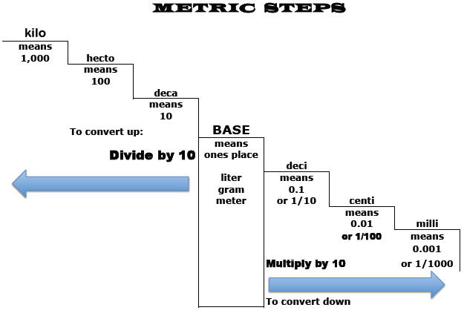
Move Decimal RIGHT the # of steps taken
Move Decimal LEFT the # of steps taken
Prefixes: (all are lower case letters)
Volume:
1 cubic meter (m³) = 1000 L = 1 kiloliter (kl)
1 milliliter (mL) = 0.001 L= 1 cubic centimeter (cm³)

kilo = k = 1,000 x base unit

hecto = h = 100 x base unit

deka = da = 10 x base unit

deci = d = .1 x base unit

centi = c = .01 x base unit

milli = m = .001 x base unit

Name ____________________________________ Date ____________________Period _________

Metric System Practice

LENGTH: Convert each measure as indicated.
1. 92 cm = __________mm 2. 6.1 m= __________mm
3. 70 mm = __________cm 4. 736 mm= _________cm
5. 12.2 km= __________m 6. 9800 cm = _________hm
7. 456 m= ___________km 8. 4 km=_____________m
WEIGHT
9. 76 cg= ____________mg 10. 90 mg= __________cg
11. 266 g = __________kg 12. 3 kg=__________mg
13. 2000 mg= _________dg 14. 76.45 mg =_________cg
VOLUME
15. 58 cl= __________ml 16. 3.1 L=____________ml
17. 712.3 L=__________kl 18. 30 ml= ___________dl
19. 0.22 L= __________ml 20. 0.45 ml=__________cl
Measurement |  | Convert to Metric Units
1 | 23.6 cm | m | mm | dm
2 | 456 mm | cm | m | hm
3 | 6.89 km | hm | m | mm
4 | 77.8 dk | m | hm | km
5 | 0.97 m | mm | km | dm
6 | 89.078 ml | l | cl | dl
7 | 8.55 l | kl | cl | ml
8 | 19003.9 dl | ml | hl | cl
9 | 369118 ml | dal | l | kl
10 | 0.779 kl | l | ml | hl
11 | 2.678 kg | g | cg | dag
12 | 963.8 g | kg | hg | dag
13 | 46666.56 mg | cg | g | dg
14 | 952.45 dag | hg | kg | g
15 | 3456.0 g | hg | cg | kg

